Summer 400

It’s a hilly challenging route with no aid at controls one, three and four, so make sure to top up on water and food when you can. There are lots of opportunities for this. These controls are informational, spot the zip ties –

Control one

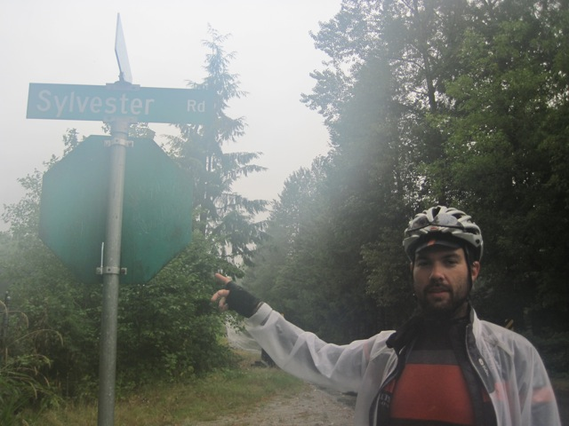

Control 3
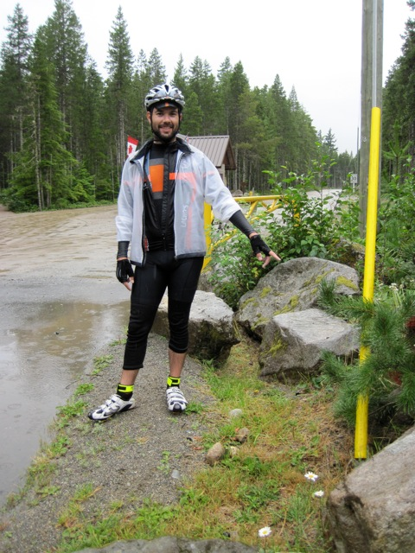

Control 4

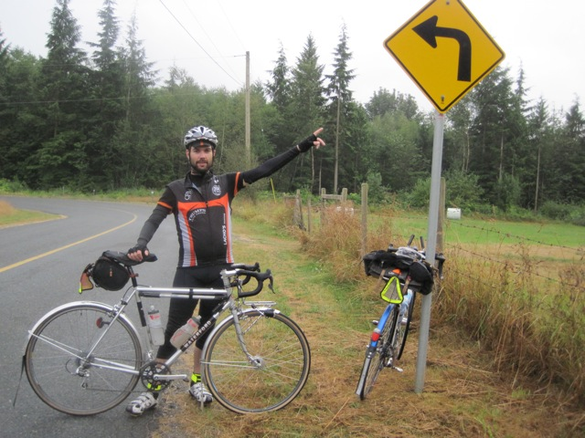

In case you were wondering and you hadn’t done this before here’s Ryan’s Garmin download of the route –

http://connect.garmin.com/activity/43697870

Be careful around Woolridge street and King Edward road because of construction, especially the metal plates if it’s wet. The Pointa Vista restaurant does a great skillet omelette. There was a lot of diesel spill coming down Columbia valley Hwy and Cultus lake road, but again I think it’ll be dry, so not an issue. The construction section on the Lougheed Hwy, after leaving Mission is not bad, but watch out for general construction debris all the way until you leave at Coast Meridian. Don’t turn onto Coast Meridian immediately after going under the bridge, that puts you into a parking lot, the real turn is at the lights.

I don’t think there was much else, so enjoy.

