Alberta’s Highwood Classic 2012
E.W. (Wim) Kok
This brevet is an absolute, especially when the weather is right. I cycled this ride back in 2004 and thoroughly enjoyed it. (http://www.randonneurs.bc.ca/newsletter/submissions_2004/039_highwood-fall-classic_wim-kok.htmlwebsite). It was time for an encore. So when the stars aligned and the weather forecast looked more than promising I did not have to think long to sign up. The Classic was also the last of the 2012 Albert brevets.
The Classic runs from Cochrane West along Hwy 1A, then crosses over to the TCH at Seebe and doubles back to Hwy 40 into Kananaskis Park and that’s where the fun really starts. From the control at the Barrier Lake Visitor Centre (Km 65) the road steadily climbs at a manageable grade to Fortress Jct (Km 99). After that the climbing gets a bit more serious to the Highwood pas (Km 126), which at 7,239 feet a.s.l. represents the highest paved highway in Canada. After that it is basically downhill all the way to Highwood House and then level to Longview ( Km206). It then goes back to Cochrane via Black Diamond, Millarville and Bragg Creek (Km 274), but not before being challenged by a few rollers en route. (http://www.albertarandonneurs.com/maps--calgary-highwood-classic-300.html)
Departed in the dark from Cochrane. Robert Martens, a cycling friend from Fort St John, joined for the ride. We raced together in the past and cycled a number of long distances in the Peace region and around Cochrane. Barely 15 minutes in the ride we were surprised by a large elk in the middle of the road. Not that long thereafter a few deer cleared the fences. Further ahead fog filled the valley in a few places stretching across the road. In some places the fog formations displayed interesting shapes – visible evidence of the dynamic interaction between temperature, moisture and air currents. At Highway 1X we turned south and then east on the TCH to Hwy 40, the entry of Kananaskis Park. A large coyote sauntered across the junction 1/1x junction. The first control (Barrier Lake Visitor Centre) was still closed.
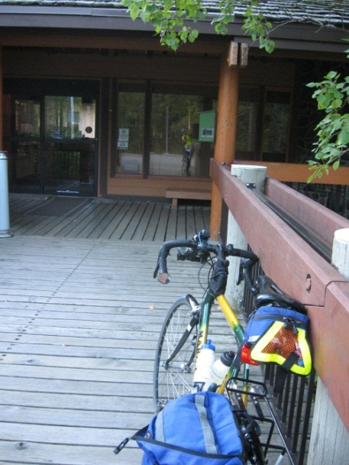 Control 1: No-one home

Continued on to the next control at Fortress Junction, 34 km further up the road. The valley narrowed, the mountains rose, as did the road. The scenery was outstanding. The air was still crisp. Saw a cow moose along the road. At the Fortress Junction store we resupplied, took off the legwarmers and digitally captured some of nature’s beauty.
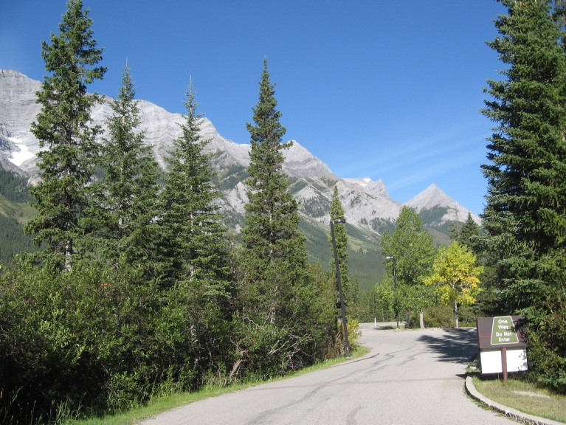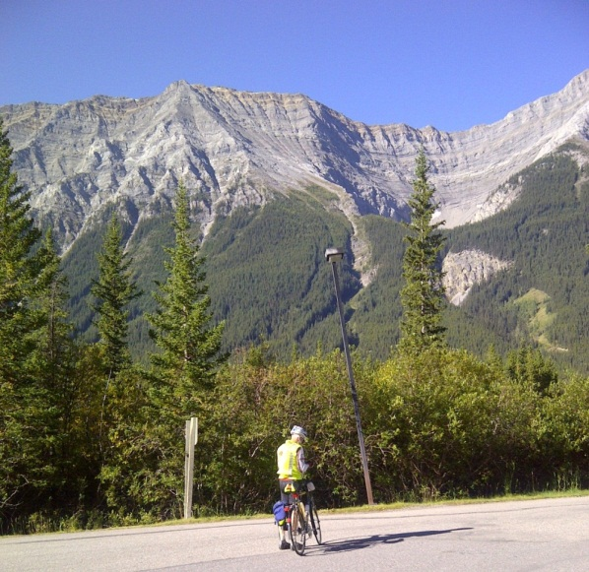
Fortress Junction looking NW Credit: Robert Martens
Next up the climb to the pass, elevation, some 7239 feet above sea level. The climb was long and steady; there were a few sections where the grade eased off. As we ascended, the terrain became more rugged, more impressive. Foliage on fireweed was bright red in places. Colours on the one hand were bright against the clear blue sky, yet subdued in other places when contrasted with their surroundings. I am sure that the thinner air contributes to nature’s clarity. Words cannot describe the incredible beauty of this alpine environment, nor can a camera capture it. One has to be there to absorb it. In this setting we progressed and made it to the summit. Breathtaking in more than one way!
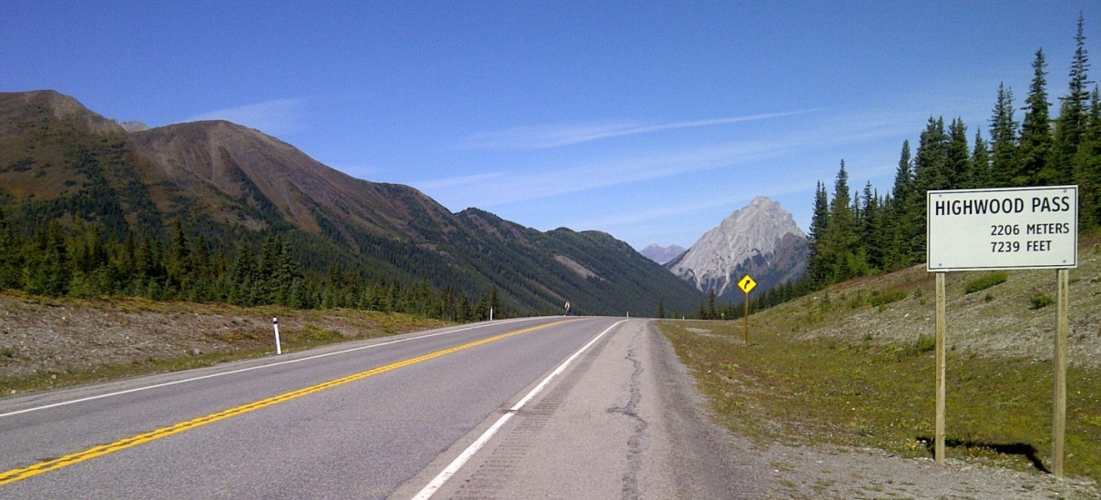
Approaching the Highwood Pass from the North Side Credit: Robert Martens
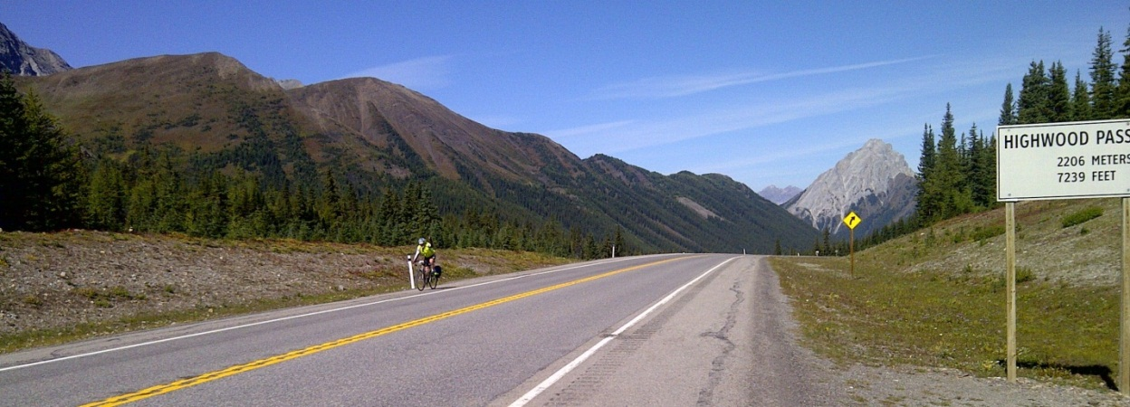
Just About There! Credit: Robert Martens

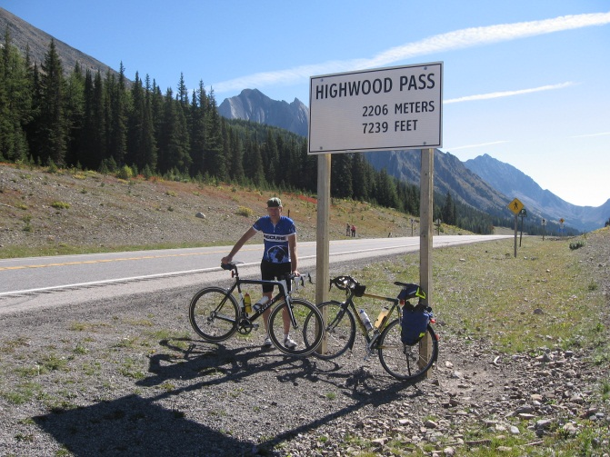
Robert at the “Col de Highwood”
Passed the peak and then descended at considerable speed. We stopped briefly at the site of the Lost Lemon Mine interpretive sign for drink and bite. As we did so, Peter Hoeltzenbein passed us at even greater speed, head down, obviously oblivious to us. We resumed our descent for many kilometers, immensely enjoying the scenery and the ride.
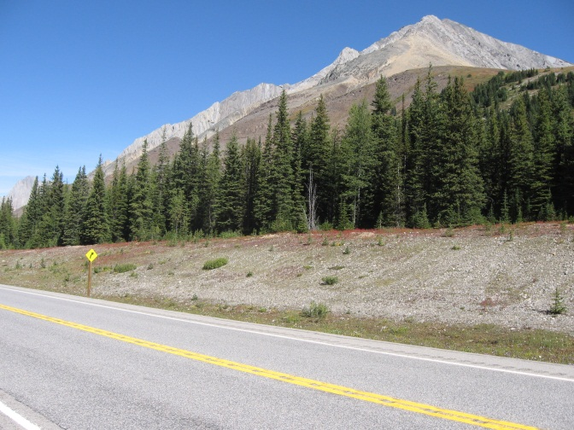
Highwood Pass peaks
Past Highwood House the route turned NE, while the winds were southerly. The result: no need to cycle anymore, because the winds gave us wings. Para-sailing may be the better description. We left the mountains behind us and with it the allure of the landscape. The terrain became flatter, the vegetation grassier and drier, overall less impressive. Mentally it became a bit of a challenge to cope with this. While we wondered when the next control would show, it was not long before we arrived at Longview. We sat down for soup at the Little New York Bistro and then on the road again. The 17 km section to Black Diamond was a bit of a struggle as I was waiting for the soup’s energy to kick in. I briefly stopped in Black Diamond at a Vietnamese restaurant for a control stamp/time. Here I had to explain to the owner the purpose of this. Somehow the owner was impressed and he inquired about my age. From Black Diamond a brief ride to Turner Valley after which the route zigzagged its way N-W-N-W-N via Millarville to the Bragg Creek control. Here we ran into Joel Paschke, who must have passed us as we sat down in Longview. He did not, and it looked like he suffered a bit. A few customers at the gas station were curious about our cycling activity that day, so in a friendly banter we explained it our purpose. We did not stay too long, for there was another 30 km to go to the final control. We wanted to be back before dark. With a gentle tail wind, we easily pushed a speed of 30kph. For the first 10 kilometers or so, we towed Joel along, but as he recovered and slowly gained strength he finished very strong. The ride had taken 14:08, which was of my fastest 300s. What a ride it was. A gift to savour! Finally, thank you to Robert and his family for the hospitality and the ride. It was fun.
* * * * *

