November 25, 2011

Union Bay Market
5555 South Island Hwy,
Union Bay BC,
V0R 3B0
Dear Great Folks at Union Bay Market

My name is Jim Runkel. I help organize rides for our club. This year and in years past, your establishment has been used by our club as a control point for rides. You have graciously allowed us to stop off and get our control cards signed and for that we are thankful. I am sending you a Volunteer Pin, which we give to those who help make our rides successful.
Here is an example of a Control Card. By putting an initial and time in the appropriate box you are verifying that we were at your establishment and the time we were there. There is NO responsibility on your part when you do this.

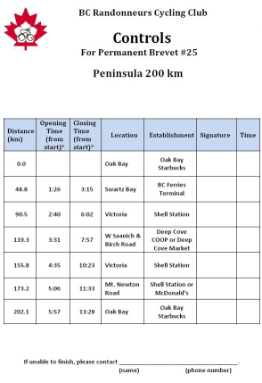
On behalf of the VI Randonneurs, I want to thank you for your support, by signing our Control Cards. Please check out BC’s excellent website for more information
http://www.randonneurs.bc.ca/

A bit more information:
Randonnée, a French word for ramble or tour, describes a long-distance cycling event where the participants follow a prescribed route within certain time limits as checked at control points along the way. Riders, called randonneurs, cannot receive support, except at the designated control points, so each rider must be prepared for mechanical mishaps, changes in weather, and so on.

The shortest distance we ride is 200kms. After that there are 300, 400, 600, and 1000 + km rides. Every 4 years (2011) is an event held in France called Paris-Brest-Paris (PBP), which is 1230 kms and attracts ~5-6000 randonneurs from all over the world. This year I was one of 2 Island riders who attended this event, and many of the rides that came through your establishment were used to help us qualify for this world class event. Both of us from the Island were successful at completing PBP in 85 h and 50 min.

