Winter Training in the Peace Region
By E.W. (Wim) Kok
Living in part of the world known as Canada’s Sub-Arctic means that its habs have to endure long winters, long nights, short days, low temperatures, severe wind chills, persistent snow and icy roads. These Siberia-like conditions are no picnic when it comes to cycling training for such events like Paris-Brest-Paris, the 1,200 km brevet scheduled for late August. The qualifying brevets should ideally be completed by mid-June or sooner. For northerners that leaves a rather narrow window of about 3 months at best to get ready for the series (200, 300, 400 and 600 km) and to get them done. Some enthusiasts try to get an early start on the road. There was this recent announcement for a Frosty 200 km near Tillsonburg, Ont. - followed by an update which noted that the “worst conditions are snow packed roads and the best conditions are bare but wet. Most of the roads are at least centre-bare with snowy and slushy sections.” (http://www.randonneurs.bc.ca/newsletter/submissions_2011/017_randonneurs-ontario-frosty-200.html
For the geographers in the crowd Tillsonburg is near latitude 43 N, some 1,450 km further south than Fort St. John, B.C. This led Ken Bonner to note that these Ontarions must be my kind of people. He expressed surprise that I was not one of the riders registered for that event and even speculated – jokingly - that I might be stuck in snow bank somewhere. Admittedly, I have cycled in those sub-zero conditions, blowing snow and past sizable snow-banks. See also http://www.randonneurs.bc.ca/newsletter/submissions_2007/020_peace-rider-cool.html
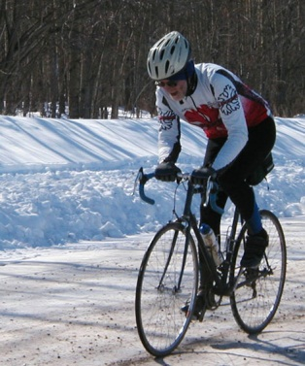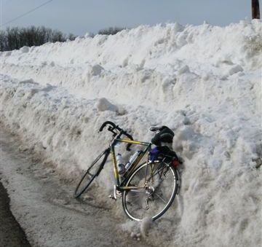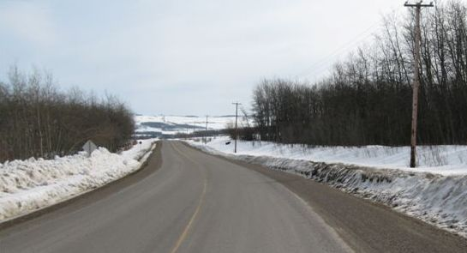
http://www.randonneurs.bc.ca/galleries/gal_2005/photo-pages/wim-snow.html http://www.randonneurs.bc.ca/newsletter/submissions_2009/018_peace-pop-photos_wim-kok.html
My response was that considering those conditions one would indeed conclude that they are my kind of people. Of course they are!! For me however a saner head does prevail. I don`t have a lot of desire to ride in those conditions. What does it prove? That one can ride in the snow? Great adventure for sure, why not. Why, because it is there. However when the snow conditions are really good, I’ll resort to cross-country skis to glide over snow drifts, if one gets my drift. The reality is that road cycling north of 56 in the BC Peace is usually to 6-8 months. Granted there is bit of jealousy on my part when I hear about 200 km brevets in Florida and California in January!! However as the saying goes ‘jealousy gets one nowhere’, not even to the Sun Belt, so I resort to alternative training methods. For me they are (1) riding the rollers and (2) speed skating.
Roller training is not considered one of the sexiest forms of training, especially in a basement. The advantage however no snow-banks, head winds, wind chills and challenges like icy roads. It’s much closer to home; actually it is at home. Close enough for my comfort. To make the exercise attractive I decided to ride PBP in virtual fashion. While riding the rollers I imagine cycling from St. Quentin to Brest and back. With the route sheet for each stage attached to the handle bars I am rolling along, peeling off one kilometer after the other, passing through one community after another and ticking off one control at a time. I also keep a diary with notes on my progress and places I`m virtually rolling through, memories from two previous PBPs (2003 and 2007), and quirky things that do come to mind as I am actually going nowhere.
For me it is an incredible motivator. Spending up to two hours in the saddle, 2-3 times a week, and dripping from sweat – guess that’s my way of riding in the rain --- not only builds character and mental toughness, it also toughens the contact zone between body and bicycle: the derriere. Temperature-wise I crank the thermostat up to +21C, which means that I have FURNACE 21 conditions!! This is one of my ways to build base (-ment) mileage for the upcoming season. My goal is to complete the virtual PBP by the time the roads are ready. On Feb 20, I (virtually) arrived (virtually) at Corlay, Km 747. Six months to the real one! 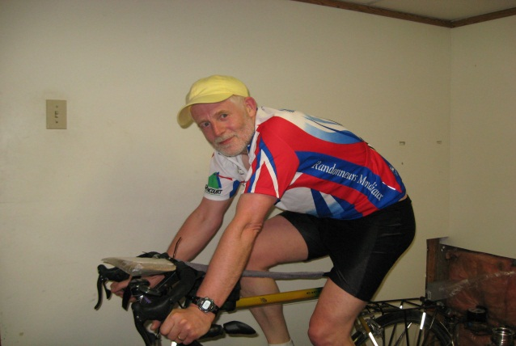 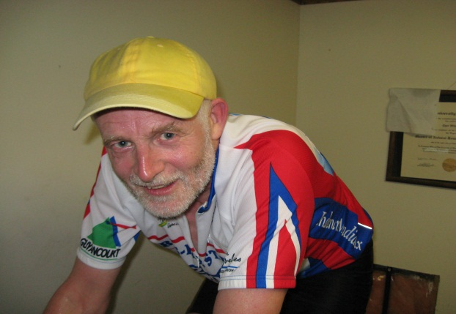
Riding the rollers. Photo Credit: Ricky Kok.
My other winter activity involves long and short track speed skating. As one of the hotbeds of speed skating in Canada, our local club has been running speed skating programs since the mid 1960’s with an impressive track record of close to 90 international, national and provincial titles and numerous records. That’s not counting the two winter Olympians from this club: Linda Johnson-Blair (Lillehammer, 1994 and Nagano, 1998) and Denny Morrison (Torino 2006, silver and Vancouver 2010, gold). Up to a few years ago we`d be skating short-track in indoor hockey rinks from October to the end of March with an 8-week long track intermezzo on a 400 m outdoor oval (natural ice) from mid-December to Mid-February. That was a great winter fitness activity.
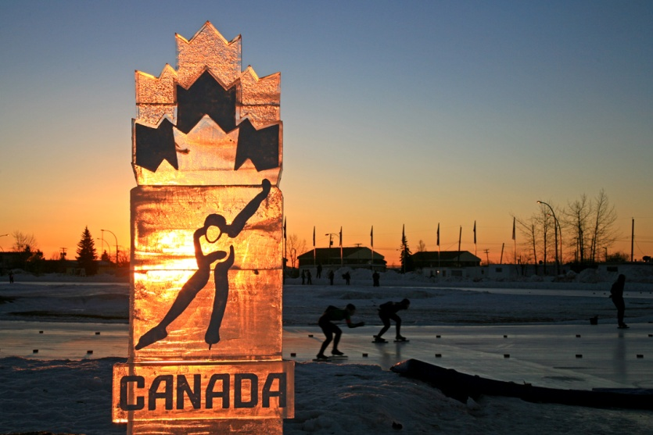
Sunrise at the Fort St. John Outdoor Speed Skating Oval during Canada Cup #2 January 2007. Photo Credit: Arno Hoogveld.
Then somehow the stars aligned themselves over Fort St. John and something magic happened. Around the time the Winter Olympics were awarded to Vancouver and Whistler, the City of Fort St. John put a proposal forward for a sports centre that would include a 380m indoor running track, two NHL size hockey rinks and-- get this -- a 400m indoor speed skating oval at the 2nd floor. To keep an unbelievable and fascinating story short, the municipal government was able to convince the province and local citizenry of the merits of the proposal. The facility is now a reality. Final cost about 43 million dollars, which includes a magnificent landscaping job. Since the Richmond Olympic speed skating oval was discontinued after the Games, there are now only two 400m indoor speed skating ovals in Canada: Calgary and Fort St. John. Every time I step inside the building and onto the ice I am wondering whether I am dreaming. However when I pinch myself, nothing changes. Dreams are and do come true.
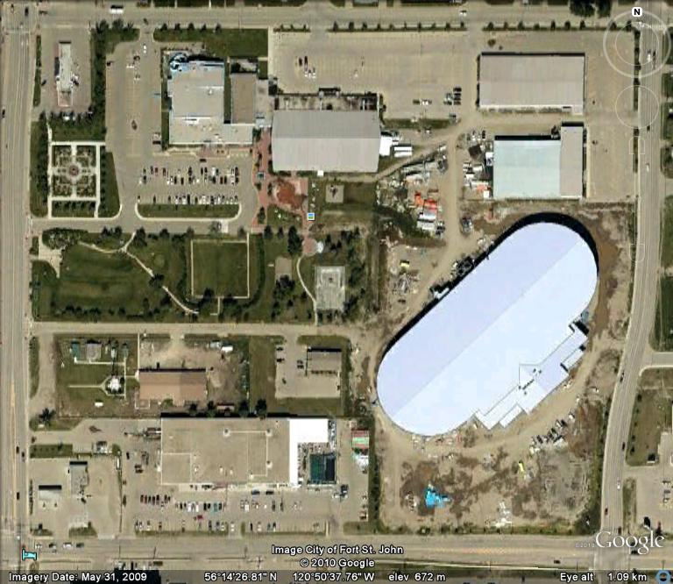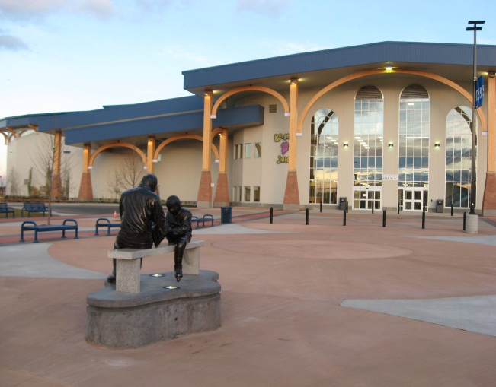
Google Earth View, May 2009 Pomeroy Sports Centre, October 2011
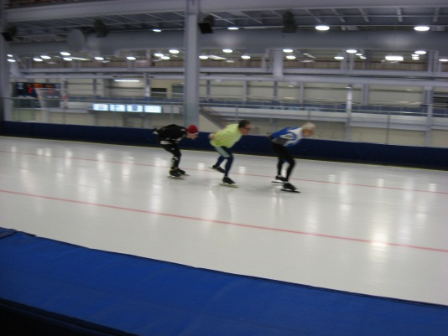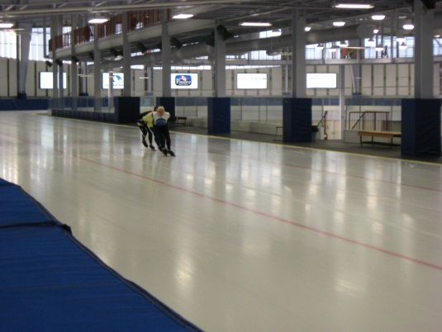
From left to right: Jay Morrison, Ken Johnson and Wim Kok skating laps at the 400m indoor speed skating oval in Fort St. John, B.C. Feb. 12, 2011. Photo Credit: GoogleEarth, Wim Kok and Robin Sipe 2x).
We – I am humbled to say that I have been part of this incredible organization for over 25 years - now run a 7-months speed skating program from September to March in both long- and short track. There’s more to come yet; through corporate sponsorships the City raised close to $ 3 million dollars, all of which will be spent on sports programming for the next 15 years. This will include a High Performance Training Centre to be operated in conjunction with Pacific Sports of the Canadian Centre for Sports. We are as pumped as a bicycle tire at 115 psi!! It also explains why during the winter months I feel no need to compete with Old Man Winter on icy roads. The indoor ice is good enough for me. Two to three times a week I don my clap skates, skate laps, do speed routines and technical drills on the long track oval. I am training with the fastest athletes in the region. What a thrill! I’m a very lucky man! We have been skating on the oval since Christmas 2009. At the beginning of the 2010 outdoor cycling season I noted the relative ease with which I could climb the hills. Those squat positions during skating definitely paid off for cycling. For that reason there is little need to venture outside on the short dark days on either side of the winter solstice.
* * * * *

