Gary Baker
He’s 60 and Still Going Strong!

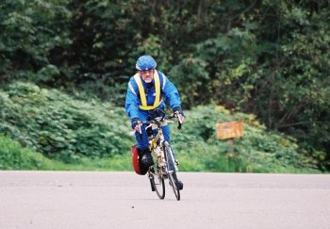

Randonneur Extraordinaire

Special Achievements to Date

Cranky Knee
Torn Shoulder
Anal Fistula (now that’s got to hurt!)
Concussion
Broken Ankle
Fractured Vertebra
Multiple Hematomas
Sprained Thumbs
Irritated Eyeballs

This man will not give up…
PBP in 2007!!

Happy 60th Gary

From Your Sympathetic Friends, Dan, Jennifer & Eric

