PBP Paris - Brest - Paris 2015
Olympics for randonneurs

Madness has many faces. Mine too.
Magny-Les-Hameau, Parisian countryside. From the window I only see pouring rain, inside me the cold of the storm. The arena is close, it doesn’t matter what the weather forecast says, I will jump in. What will my body say in those days?
In that flat I’m waiting to face the challenge that a mean sport newspaper editor made in 1891: riding a bicycle from Paris to Brest, touching the ocean in the westernmost point of France and coming back to the Ville Lumière, all in less than ninety hours to flavour the battle. Going up and down from the room to the reception doesn’t help me dissolve that strange restless boredom. “This must be the last detail, I wanna stop with the arrangements!” There’s no cure, except beginning to pedal.
Tension mounts, concentration is at its peak and a sort of “killer instinct” is growing inside. I will leave nothing to chance during the race, devoting all my efforts to reach the final target, with that “healthy cruelty” born from the resolution to crown a year of efforts. All will merge here. Mad night bike rides, circumstances when the body reached the extreme, small tricks to preserve energies for as long as possible.
Being at the Olympics of randonnées requires all of this. Senses expanded to the maximum, at levels not needed in the routine. Adrenaline, natural drug, will begin to flow in my veins and sharpen every detail, lighting (almost) every instant of those semi-sleepless nights. The head commands, the body follows, both of them supported by that fantastic Breton-Parisian climate.
A long snake of velocipedes will advance towards the Atlantic: a “rolling tower of Babel” as someone named it, the world speaking the common language of cycling during this challenge renewed by the Audax Club Parisien. It seems like living a dream.
Audax means bold. And bold is the tiny and gritty Japanese woman on her prestigious Masi, made in Milan. But also the Greek man who will pedal head high near the German giant. The Russian man from Saint Petersburg with his Cyrillic t-shirt Star of the Baltic will face his white night. The South African dad will watch those two puppets on his handlebars thinking about his kids at home. Bold is the randonneur from Alaska and his ‘neighbour’ from Kamchatka, I thought it only existed in Risiko. Bold is the Bulgarian giant Tzezo, two meters and three centimeters, I’ll meet him smiling at the checkpoints. Or his compatriot Georgi, now living in Washington D.C. but still nostalgic of his origins.
Bold are the two Italians Piero and Graziano with whom I joke and share encouragements, feeling that a flag is something more than three colours placed side by side. And the Frenchman Alain who has climbed an eight-thousand-metres peak. The Ukrainian guy from Odessa, the Basque-Spanish man, the Serbian and the Bosnian rider, everyone with his or her history, on and off the bike. Bold is the Indonesian man with whom I try to communicate without success, he remains beyond the wall of language and fatigue.
Audax is my inspirer, as well as rando companion, Stefano. He is ‘guilty’ for my participation. And we’ll arrive together at the finish line.
That snake is composed of men and women of all ages, from 18 to 84 years, all of them engaged in a common approach path and ready to jump into the final trial, their training as their only parachute.
The velodrome of Saint Quentin en Yvelines is quiet when we arrive. Ostensible calm before the great event. Ash and Lax, from India, have dazzling smiles and great resolution. Arrived in Paris a few days earlier, they try to overcome jet lag, even though during the race they won’t need to have a regular sleeping pattern anyway. Riders continue to gather in this temporary world Mecca of the bicycle.
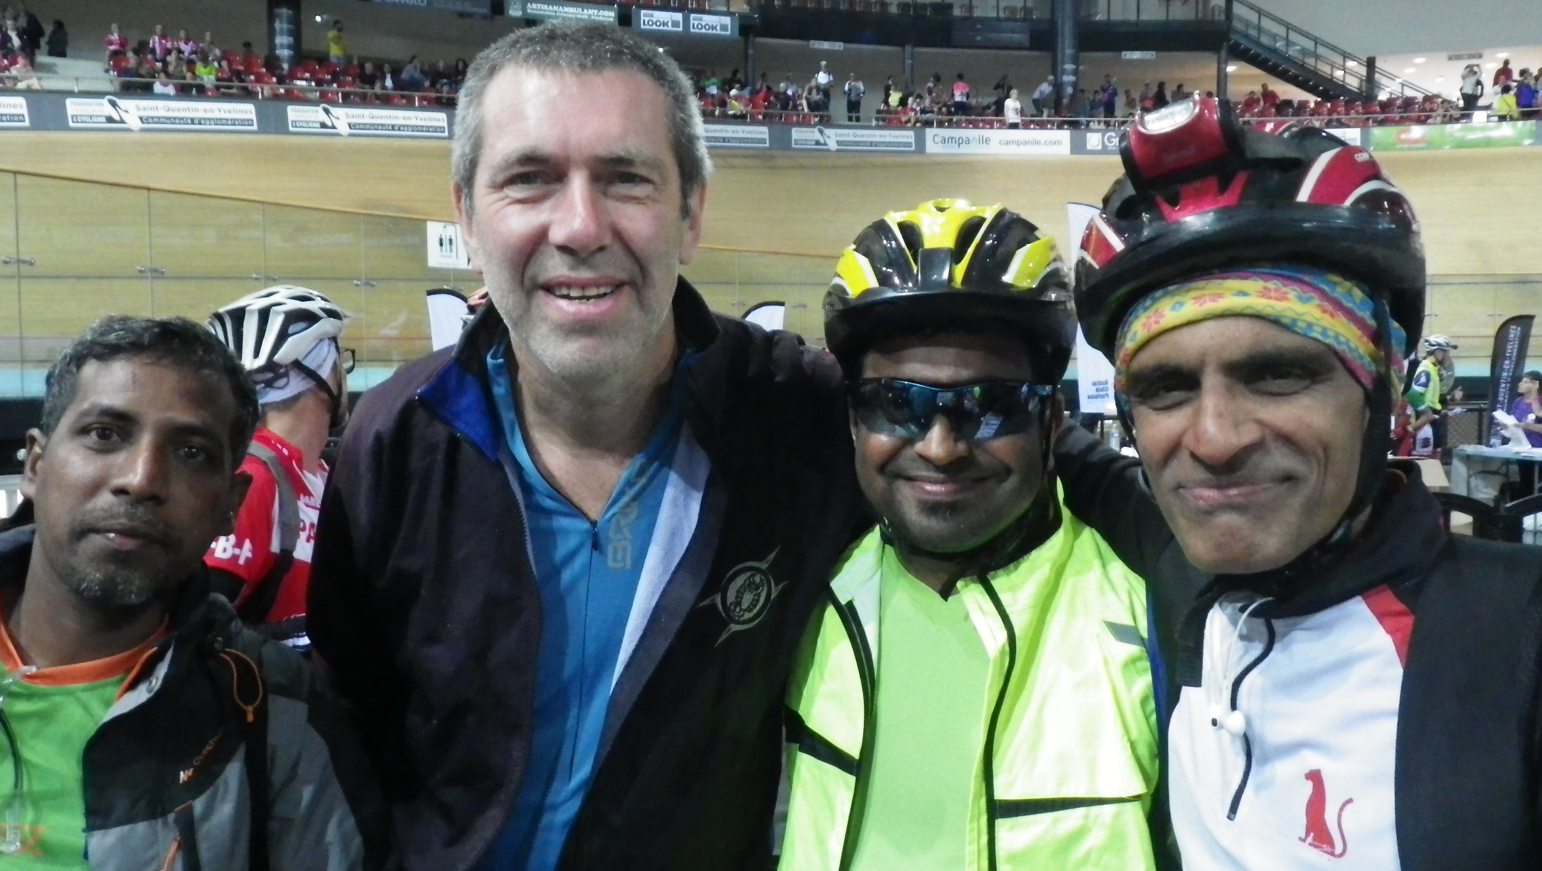
Versailles is a few steps away, the Eiffel tower at some more pedal strokes, it would be fantastic to ride the Champs Elysées on the bike like the big names of the Tour de France. Instead, we go for long walks between Notre Dame and the Beaubourg, from the markets of Les Halles to the Louvre, the Tuileries gardens and the Gare d’Orsay. I breathe an air of tolerance and good taste. Nothing indicates what will happen only three months after at the Bataclan and in the rest of the city. Respect of the rules and good public utilities seem to make coexistence easier, and watching so many young French families gives you trust in the future.
On Saturday the waiting is almost over, rendez-vous at the velodrome for the bike-check. I meet Bill, skilled and not really thin Californian randonneur. I see the two Indian friends again, and the atmosphere is immediately more relaxed in that big crossing of existences. Two benevoles, volunteers wearing a violet t-shirt, inspect my bike and assent. Lights are ok, all is anchored to the central body. The long queues at the velodrome begin: you have to pick up your carnet de voyage, reflecting night vest, bike nameplate and id card that will let you go in and out of the race-area. Welcome to the magnificent world of the super randonnée!
Load test in the afternoon, around forty kilometers to taste the côtes, gorgeous ups and downs through the woods, and to pay proper tribute to the monument to Jacques Anquetil, five tours de France in his carnet. On that day Saint Quentin becomes exceptionally crowded by the cyclists and their partners, six thousands participants, six thousands different histories that merge in a common and intense experience. It’s not an every day opportunity entering a velodrome, it makes you dream to arrive there covering the last ring amidst the cheering of the crowd, just like at the end of the Paris-Roubaix. It’s the prelude to the start of the randonnée, when all ties come undone, when you finally get face to face with the Paris Brest Paris, without further ado. Like real Italians we prepare a generous amount of pasta to take with us on the bike, more for its simbolic value than for its caloric one. We also pack some sandwiches and some energy bars in case of super-crisis.
On Sunday morning we arrive out of breath for the group picture of the Italian team. We are not the only ones “not exactly on time”; among the big group of Italians we meet friends known at the brevets, a lot of very courageous women, two daredevils, Alberto and Simone, with fixed vélos d’epoque with acetylene lamps, a super-determined Mirco with his handbike, the team mates of SAV psyched up as usual, the national champions dressing their tricoloured jerseys. After that morning crowd bath we find a quiet place for the last lunch before the battle. We spot a play area in an adjacent residential zone where we can gather our energies for the first night. Rest and tension coexist and will coexist in the next few days, the trick is letting the mind find the right balance between the two.
At four pm comes the gunshot: group A starts, those who bet on finishing the race in less than eighty hours. We’ll start off gradually, in so-called pelotons, groups of about three hundred people marked by different letters. Preceded by motorbikes and cars of the meticulous control service the participants begin to spread out along the route over a hundred kilometers. At the second kilometer, we join the Parisian crowd that cheers the athletes. We already carry all the identification symbols, on our helmets and on our bicycles, that betray our imminent departure, and so, although still part of the audience, we are honoured with compliments and encouragements.
Leaving is already a victory, embarking in a giant challenge that will measure our forces and our limits. We move to the velodrome zone, ready to face the last steps of the wait before the start at 7 pm, group N. Near us different idioms, skins of many colours, jerseys with a lot of flags. The strangest vehicles (tandems, trikes, torpedos, recumbent bikes and elliptical bikes and so on) started at a quarter past five pm, we’ll begin to find them later. We enter the gates like bulls before the bullfight and, after the start of the preceding group, we line up at the starting line accompanied by a speaker and powerful music. The body is restless, the mind is on edge.
Then the countdown and… we’re OFF! For the first meters, we almost walk while the maze unravels, then comes the first bend and the big exulting crowd that will cheer us for some kilometers. The air is fresh, the climate surprisingly favourable and the forecasts say it will be like this for the next few days as well. I wear two bike jerseys, the national one on sight, even if I’m not typically sensitive to the cold. I was just hoping for fresh weather, between strong rain and hot sun, “tra piog e so” as my cousin Carlo says. My wishes seem to be granted and from the first pushes on the pedals I feel positive sensations while rolling in the group at good speed. “Maybe I’m going too fast” I often tell myself, I’m ready to temperature lowerings thanks to a generous luggage, I would not be so ready in case of reiterated rainfalls and cold.
“Que sera sera, whatever will be will be” as a famous song says. I lose and find again my friend Stefano, as I will during all the race. I chat a little with Aleksej, a stammering guy from Saint Peterburg I am going to see again many other times. Meanwhile I keep an eye on manholes, sidewalks, traffic islands, wet asphalt, slow and fast moving cyclists, cars, motorbikes, cheering inhabitants of the villages. The roadway often becomes narrow, falling is all too easy and would spoil months and months of training. Kilometers begin to add up, and after three hours the bike falls in the dark, I turn on the lights and wear the safety vest.
The road often goes up, and down, and up, and down. Sweet côtes, the legs feel them with enthusiasm, cycling in fresh air is pure pleasure. I hope it will last… for the moment it’s real! Along the journey I come across many huge-sized riders, so that I feel unexpectedly normal, I who am almost two meters tall and weigh a hundred kilos, amidst all those giants, many from the North, I meet on the route to Brest. At around the hundredth kilometer we start to pass the stands organised by the fantastic families along the itinerary. Coffee, tea, stock, plumcake, water, a lot of warmth to welcome every single person stopping by, something considered as a real privilege. Women, men, teens, all busy to take care of the succession of athletes.
Since the first kilometers I have begun to see cyclists stopping on the roadside, some for a repair, some to arrange their luggage, some for physical needs, some already to sleep along the edge of the road. In this phase more than in others I try to understand which is the right rhythm to maintain and frantically search comfort observing the plates of the cyclists surrounding me to note if I’m earning or losing placings. The feeling is that I’m rolling just fine. The first night many trains pass by on imaginary rails… The fastest riders of the groups that have started after us gradually reach us, and I try to keep up with them for a while, before letting them go so as not to get too tired. The road is scattered with objects of all kinds: lights, batteries, energy bars, inner tubes, glasses are the most frequent, so that one could fill a stand with all the bounty you see around in this first phase.
The group rolls surrounded by the jubilation of the crowd, that makes every single adventurer of the PBP feeling like a hero, it doesn’t matter if he or she is among the fastest rouleurs opening the way or among the last ones cycling at a less allegro pace, after hours or days from the first transit. I roll by too and seeing the children that put out their hands searching for a five feels me with an incredible elation. I laugh and cheer, give and take energy, as long as I have it in me. And it seems to me that it’s never going to run out. I will find again some of those people in the same exact place two days later, I will see them again at a stand, sitting on a wall, at a window. Hallucination or reality? I’m afraid it’s all true.
After 140 kilometers I arrive at the first refreshment point without control in Mortagne-au-Perche: outside there are stands where they fry sausages and other food; inside people are already queuing at the self-service. I fill up my water bottle and cover up to face the freshest part of the night. I want to avoid muscle strains or joint pains and all the dampness of the French woods has to be blocked somehow. Traffic is very limited, the groups occupy the whole road, only to return in their half, as if by magic, when a vehicle approaches. Night is night, with its silence and the rolling of the chains, more and less powerful lamps, reflectors, glances sometimes careful sometimes absorbed, thoughts wandering among r.e.m. phases.
After 220 kilometers it’s almost five am when we arrive in Villaines-la-Juhel, first control. Big crowding of bikes, you need a good eye to understand which is the best position to leave your vehicle. I pass my transponder at the entrance of the checkpoint and sensor register my transit; then I take out my carnet de voyage to receive the second stamp for further manual check, after the first one I got at the start by a laughing volunteer. Three hours is a good margin, I can invest a part of it, without wasting it all, to eat my pasta and let the limbs rest. Every time starting again requires graduality, the muscles always need warming and sometimes stretching not to get too rigid. The first morning breaks, I turn off the lights and progressively take my clothes off. I think about the next checkpoints: one every eighty kilometers, which means four/five hours breaks included.
Breakfast means croissants at local boulangeries, a coffee someone offers you is even more tasteful, and then back on the road to Fougères. In this stretch I meet two huge South Africans, Gideon and Ernst, with whom I exchange impressions, common experiences that have taken us to this PBP. My bike has no mechanical problems but one: the back wheel seems to swing a little. Is it feeling happy to dance towards the roads of Bretagne? It must be called to order for this excess of playfulness. Having avoided the threat of a broken spoke, at the control in Fougères I profit from the mechanical service and there I meet Antonio, the current Italian randonneur champion, facing a more serious problem. It takes me an hour to have my problem fixed, but at last the “dancer” goes back to a more monotonous and profitable fluidity. I thought first about my bike and then about myself, a good sign of physical freshness. I devour a good sandwich jambon and fromage and guzzle a liter and a half of mineral water to reintegrate liquids.
We leave again at midday heading for Tinteniac. The day is quite fresh, French villages go by with their greyish silhouettes and the coloured gaiety of their inhabitants. I’m still in a “cycling known land”, i.e. a distance I have already run, but my mind is thinking ahead to that part of inconnu we’ll deal with tomorrow, the territory over 600 km. The stretch till Tinteniac is short, the shortest, and pretty simple. We shop for groceries at a local supermarket. The idea is shared by many cyclists, Germans above all, who confirm the claim made by a local newspaper, that the race also represents an economic resource for the territory. Along the road I see bikes hanged on walls and decorated with flowers, gigantic bikes, bikes with ironic signs such as “the tuna fisher is waiting for you in Brest” or boards paying tribute to the village idols who are participating in the race. The Tour de France passed here only one month ago. The passion for the bicycle is palpable here and gives me strength. I also notice that the bikes of many Asian riders have funny brands, like Cimarello or Tifosi, that hint at the Italian style, and this puts a smile on my face while I pedal.
In Tinteniac I only eat a sandwich and drink mineral water. I pass by Mirco on his handbike, we only exchange a quick hello, he is always ahead of me. Stamp, filling of water bottles and salt preparations, laundry hanging in the air and a short nap. The approach to each checkpoint is becoming a sort of little ceremony. In the afternoon we move towards Loudeac and, on a flat road, we cross the first cyclist already on the way back. He seems a motor-scooter, it’s upsetting to watch him pass with lightness and strength out of the ordinary. After about twenty minutes the chasers’ group arrives; they ride very fast too, but at least have the chance to switch places at the front of the group.
It’s 7 pm, the first 24 hours are gone. I look at my Garmin showing 442 kilometers and 3.500 meters of drop. Not bad as a loot, but will it be enough? I feel it’s necessary to recover forces, for the night, for the next days, to avoid the exhaustion that hit others in stories I heard of.
Loudeac arrives. The number of bicycles packed in the large square of the checkpoint and refreshment area is impressive. I try to put mine in a recognizable place, although my senses are a bit altered and so the distances seem to widen and reduce alternatively in that enormous crossroads. At first I go to the control room where my chip gets read, so that my time shows on the official website. Then I leave a message on a social network and find my friends well prepared: they reply immediately and their support is so warm that it gives me a strength they can’t imagine. Some cyclists are helped by companions who follow them along the way; others profit of the bag drop, the possibility to leave their luggage and find it further along. There are queues everywhere; at its most crowded, around 1,400 people are simultaneously camped here. I deal with the shortest line, for the shower, excellent investment of my time. Then I launch myself in the queue for food, I need a good replenishing to compensate for the big quantity of calories I’ve burned. At last I slip in the line for the dormitory, the longest one, that requires me half an hour. At the entrance of the gym some volunteers register me and ask me at what time I wish to be woken up. It’s now 10.45 pm and the lady misunderstands my douze et demi, half past midnight, for deux et demi, 2.30 am. I correct her with sense of duty, aware that we must leave the headquarters no later than one am. They take me to my camp-bed leaving me with a synthetic quilt, in the middle of a multitude of noises.
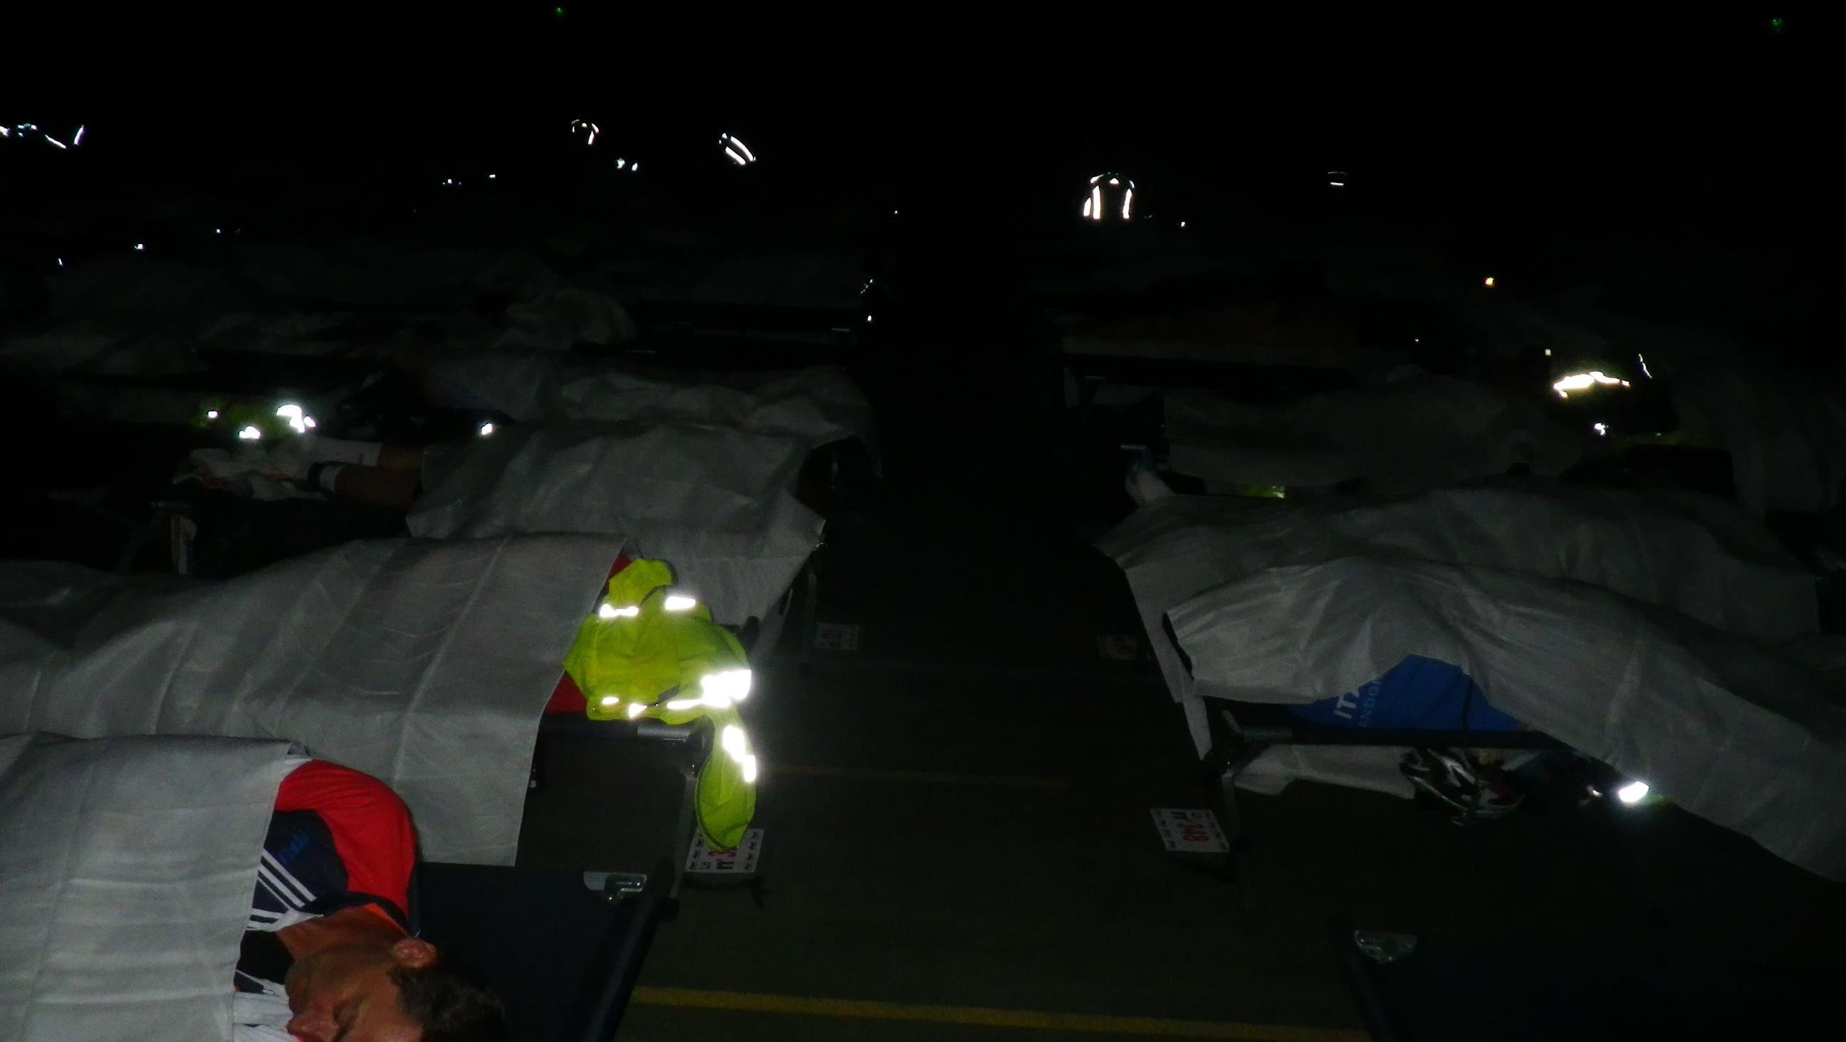
I still haven’t fully adjusted to my camp-bed when a volunteer gently shakes: the time has already come. I feel regenerated by that mini-sleep and not even so much dazed. Coming out on the large square I wear every garment I have with me to face another night. I hope to have eaten and rested enough to go on safely.
“Brest ici, Paris là bas!” the volunteers inform at the exit of the big parking, directing the cyclists towards the right destination. At the first hill I rearrange my garments, I was wearing too many. I meet Rico, a nice Chinese guy speaking a rough English, who is searching for companions for the next stretch having a similar time to the following control. After getting out of town we meet few cyclists, while on the many rises that follow I find different groups. It’s a bit difficult for me to follow Rico, he is thinner than me and faster on steep terrain, but I reach him where the slopes flatten. I hear him screaming on the descents to chase away the cold he’s not used to, even if he’s well dressed. The ramps come in quick succession and on another one I meet an English guy who has lived in Padua for a couple of years and who wants to practise his Italian. It’s night, with its magic and its intimacy that makes perfect strangers feel close to each other. At about 3 a.m. a “train” comes through: it’s the Americans, I cannot let them go. They travel regularly, thirty kms per hour, pass other small groups in the night, don’t exaggerate on the hills, guided for a long time by the same rider at the head of the group. What better could I desire to head towards Carhaix? And to pierce the fog, that huge humidity that envelops us in a surreal bubble till 9 a.m., prolonging the night and delaying the arrival of day. When we reach the secret control we are compelled to leave the train. Here the cards shuffle again, but Steve and I keep staying close in the same pack.
We arrive at about six in Carhaix. We leave our bikes in a lawn and when we go back to recover them we find them covered by dewdrops. After the control, we get in line for breakfast, while time ticks by. We allow ourselves a rest at the tables of the school complex that acts as a refreshment area, since sitting outside would mean to make a cold shower, even though it is not raining. I start again in the fog, knowing that “a’ nuttata è passata” (the night has gone) and the sun is soon to come out. Brest is in the viewfinder, the next checkpoint lies 88 kms ahead, and then the comeback will begin, I hope gloriously. In this stretch we will reach Roc’h Trezevel, the highest point of the race at 350 mts above sea level. Morning is finally arriving, the fog is dissolving. The sun finally allows us to see the magnificent Breton slopes and makes us change into a short uniform to enjoy the maximum transpiration. On the slopes of the Roc’h I feel in pretty good shape and actually head a group of riders of different nationalities to the top. The recipe works, my metabolism is alright, the amount of food and sleep is fitting to the effort required, so that I can ride with pleasure and without suffering.
A long descent leads us to Sizun, a beautiful small town about forty kilometers from the ocean. Actually I would have liked to see the ocean from the top of the Roc’h, but I have realized that it isn’t high enough to allow to see 50 kilometers ahead in the morning haze. Here too, a stop at the local supermarket is a must, we all come out with our hands full of sandwiches and yoghurt. We meet an old Breton man who speaks about his land, so geologically old, with great pride and with the love of a man who doesn’t need to go elsewhere to find happiness. At a newsstand we read signs about a death occurred the day before in the race: a senior rider with a good pace has died of a heart attack at few kilometers from his home after cycling for about 800 kilometers. Life and death cross in this cauldron of existences.
It’s almost midday when we approach Brest. We pass over the bridge on the Iroise and stop to document that highlight of the route.
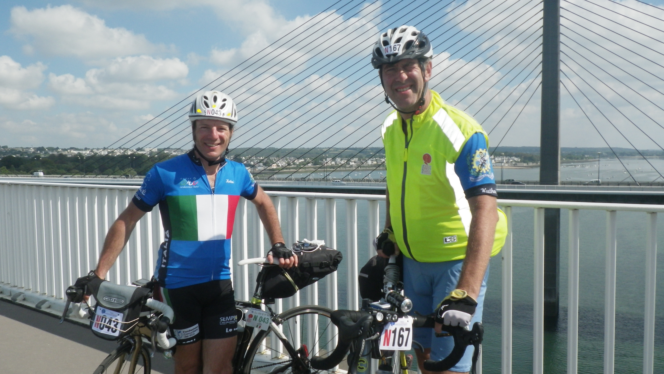
Here the Atlantic ocean curves inwards for about ten kilometers and the coast forms a big bay. At the beginning of the bay the light house, true symbol of the town, warns the sailors about how to approach this dangerous stretch of water with great biological diversity. The itinerary leads us almost by the ocean and we can smell salt in the air. The town is hilly, we have to climb steep slopes to get to the Vauban high school that hosts the checkpoint. The sun heats up the day, even if the city is normally fresh and windy. The seal in Brest ratifies that we have gone beyond our distance limits. From here on everything is like a galaxy to be discovered. Our margin on the time limit we have to respect has become slim. But we are still feeling strong, mentally as well, and that is more important. We keep calm, feed and rest at every control in order to keep pushing in the following stretch.
We come back to Sizun where we raid the supermarket again, while the salesgirls are already used to our unrestrained purchases. On the opposite side of the road we see some cyclists still directed to Brest: some belong to the group of the fastest riders, betting to complete the race within 84 hours, who have departed on Monday morning; others already know they won’t make it in time, but continue their battle regardless of their possibilities to complete the brevet. I meet Pier Paolo, Mario and Carlo: sometimes I don’t even have the time to realize they are there, and they are already too far to call them. I have seen Matteo at the Mortagne checkpoint, Stefano from Milan, Tullio and Giuliana in Loudeac. A quick and encouraging hello and it’s time to go again, with a snap-shot in mind of friends sharing a common target, every one bound to his fate. In this stretch I feel I have wind in my sails and that’s why I climb a slope unusually fast for my pace – it can’t be due to a simple energy bar I have eaten. I begin to feel that the dream can become true. In this stretch, as in a gif, I see again and again a grey-haired woman I had overcome on other occasions, and whose strengths are her agility and her perseverance. I return to the Roc’h and feel as if I am pushed by a positive vibration. Pure pleasure of pedalling. I even allow myself to stop at a camper van where some people offer me a tasting of Breton cider, even if my legs immediately suffer the blow.
I feel I’m back in Carhaix in a blink and this time I notice the flags of welcome in many languages that dominate outside the school acting as refreshment point. I can’t get too comfortable even if continuing to see those orange “Paris” signs can lead to relax: I have already cycled that route and remember well that ‘effervescent’ stretch that will take us back to Loudeac. We must accumulate calories for the effort that this delicate night will demand us. And so between Carhaix and Saint Nicolas du Pelem, secret control during the outbound ride, I fill up. On this stretch I must stop for the spot check on the way back, but I pass it without wasting too much time. Stefano starts again with impetus and I try to pass small groups of cyclists to catch up with him. I hear more people speaking, unlike the first nights when silence ruled: maybe they talk to stay awake. The night embraces our efforts, sometimes we stand up on the pedals in the steepest parts. Sometimes I notice lights on the roadside or in the wet fields: sleep surprises in the most unthinkable places. My front light goes out and immediately a motorbike comes up beside me to warn me, luckily without penalizations. After meeting again a nice local family offering refreshments, I arrive in Loudeac in the middle of the night. There’s less chaos than the first time. Only the time to get food, exchange some words with a quiet Dutchman and take a nap at a table in the self-service, crowded with people recharging their batteries. Leaving again at 3 a.m. is quite demanding and, leaving the village, I take the wrong way at a roundabout but realize it immediately. It’s the only moment when I don’t see other cyclists and keep on going alone for a couple of kilometers. Soon afterwards the Americans’ “train” passes again with Swiss precision. I join them and chat with Vernon, from Colorado, who invites me to take part to the randonnées in the U.S. The group keeps on pushing and I struggle to remain wheel-to-wheel with them when the road get steep, but catch up again on flat stretches. At the nth climb I have to leave the group, maybe due to lack of feeding. I stop in a town and, while I’m drinking something in the middle of the night outside a public toilet, I watch amused an athletic jump over the door by a cyclist who had locked himself in. Continuing in the night I have the pleasure to see falling stars, and I express a wish that’s getting true little by little.
Morning comes and with it the Tinteniac checkpoint. A funny scene follows: I show up at the registry to have my time marked down and the benevol, seeing me in mountain clothing, asks me several times if the cyclist is really me or someone else. I must show him the spikes under my soles and bib shorts under my long light mountain trousers to clear the mix-up. I regain the energies spent to maintain a higher pace and decide that I’ll have a first course after my breakfast, despite having already eaten much at the previous checkpoint. The good habit of drinking a liter and a half of mineral water at every checkpoint also helps me to replenish after the exertion. A short nap after lunch and then off to Fougères. This is possibly the sunniest day since the beginning. It’s the only moment when I feel that the côtes are really a lot. On one of them I notice 2-3 cyclists gathered to rescue another one lying on the ground, trying to revive him with CPR. All ends well, fortunately, but the pic is not so pleasant. This randonnée requires a huge effort and the risk of not listening to your body properly is tangible.
In Fougères I anticipate the end of the race and decide to change my bib shorts with new and fresher ones after an energizing shower. I want to reach Paris covering the last 300 kilometers with maximum comfort. Instead, during the afternoon I realize that the new garment strangles me and at the next control I wear again the worn-out (and usual) companions of many travels around the world. Along the way I frequently come across people that keep my spirits high with their “Bravo! Bon Courage! Vive l’Italie!” In the afternoon I get to Tannière, stopping by at a well-known stand of volunteers who offer legendary crêpes in exchange for postcards from home.
Just before reaching Villaines La Juhel I find a lively stand with a sign “Vous avez déjà fait 1001 km” (you have already done 1001 kms). What better way to celebrate that mythical moment than enjoying a glass of Pernod?
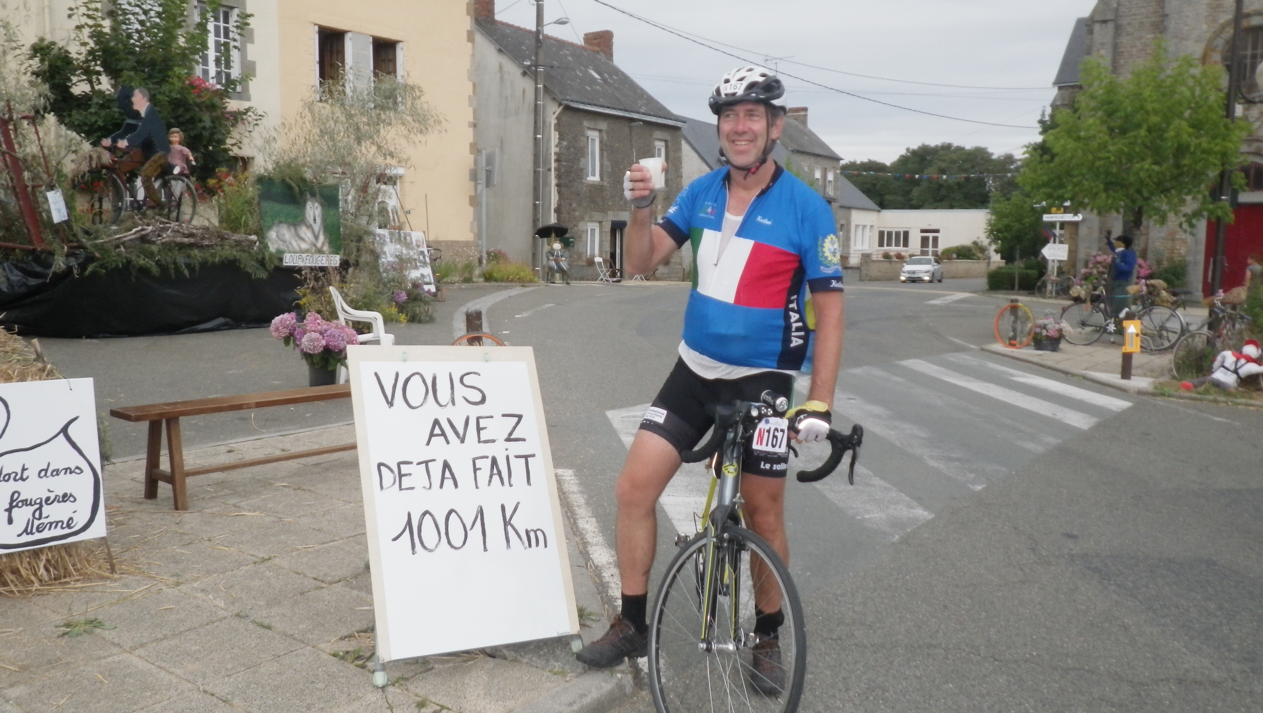
I leave the nice party saying goodbye and promising to meet again in four years, at the next edition. Five or six kilometers and I get to the check point at 7.30 pm. A big crowd of villagers cheers the numerous cyclists passing by. Dinner in the gym is accompanied by a powerful background noise, enjoyable on one hand, bothering on the other. I rest for half an hour on a bench near a couple of Ukrainians who have my same plan. It’s 9 when I leave to face the last night: everything can happen, it’s the most delicate night, even mentally, the finish line is on sight “only” 200 kilometers ahead, more than 1000 are behind us, and the mind inevitably tends to relax. The enigma that enveloped our physical condition along the way back is almost dissolved, there hasn’t been the feared collapse, but we must still hold on.
In this stretch I meet three nice guys from London, Jim, Matt and Nick. We speak, drive alternatively, so the kilometers flow more easily. I stop with them on several occasions at stands offering tea, sweets and a warm welcome, sacrificing part of the advantage I had accumulated in order to arrive within 90 hours. At the official checkpoint in Mortagne we power up with a funny gag to face the next hours leading to the morning.
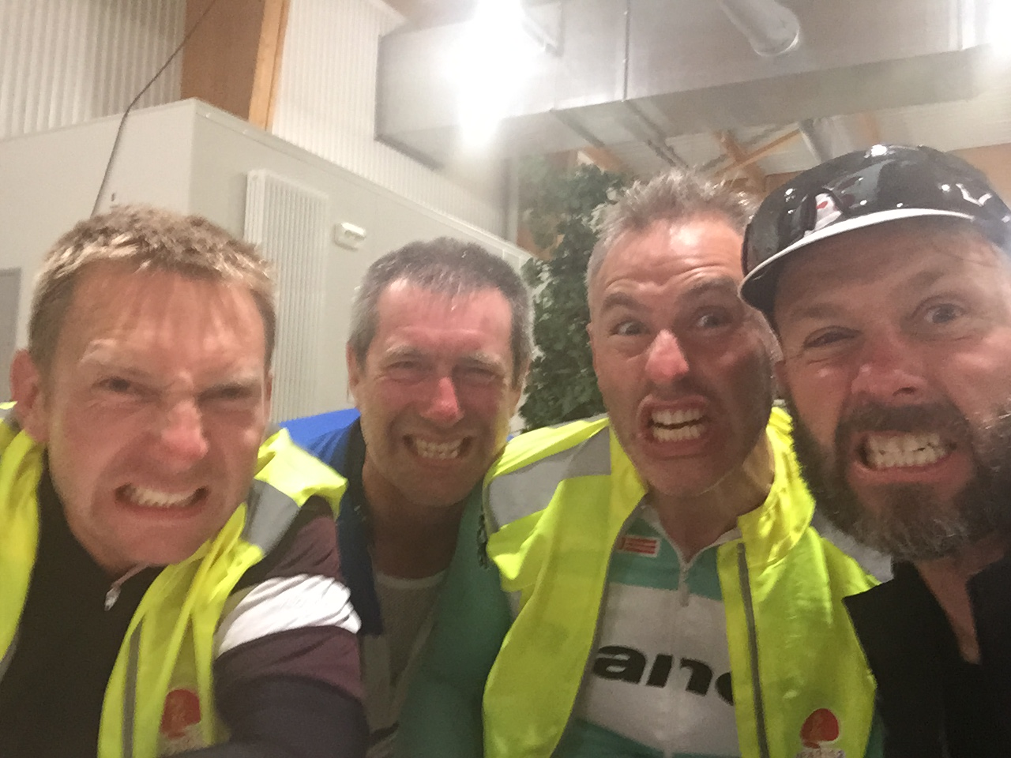
In the following stretch the PBP takes a different route, through an area we have not passed on the way to Brest, with many slopes in the middle of forests with low traffic. In the confusion of lights I lose the British trio and go on half awake, half asleep. I ride near the middle of the road, taking advantage of the total lack of cars, to avoid the risk of swerving and falling. The inevitable U.S. train passes but this time I prefer to carry on at my pace, clenching my teeth until the next control in Dreux, 60 kms to the end. The eyes struggle to remain open, the wood and the night add a dreamlike element to this part that pours slowly, while I hope to see the lights of a town soon. At the gleaming of the daylight I begin to see some cottages and decide to stop at a crossroads and take a short nap leaning against a wall, together with a dozen of other fellow riders. I hear bodies moving, as if to say “hey, you, we are going on”, and I’m back on my bicycle too. Shortly thereafter a light rain starts to fall and accompanies us to the gym in Dreux. I meet Stefano again and bump pleasantly into my friend Roberto from Udine, conspicuously relieved to have almost reached the final goal. Here I have breakfast, without stuffing myself, then back on the road under that light drizzle that seems to fall for a formal duty, since it can’t be lacking at a Paris Brest. I would sign up for this weather ten times more, could I do it. The next stretch takes us back on the same roads we took going to Brest, among villages with grey houses and stables with horses and sheep that graze quietly in the fields of the peaceful Parisian countryside. The energy is still high and multiplies at the sight of the finish line. And I need it to deal with the endless slopes, including a segment of 500 meters at 15% that tests the residual strengths of the riders. I see again, as in a film, cyclists of all kinds: the senior ones whose strength is perseverance, those pedalling slanting on one side as if they were falling down, the giant ones and those with only one leg or without an arm, those without legs completely, and at the end I understand that other people accomplish much bigger enterprises than mine.
During the last 20 kilometers I cease to eat, after guzzling superhuman quantities of food. I proceed almost by inertia, I stop pushing hard at this point without doubting I won’t arrive within the time limit, as if I unconsciously wanted to taste the last part with no rush, sure that I finally did it. I get close to exhaustion, even if eating just one of the three bars I’ve spared would fill me with new energies. I want to fully realize the feat I’ve accomplished, I would like that moment to last forever and not finish in a few kilometers. It’s a joy beyond words that invades the spirit and moves me deeply. When I go through the big park that leads to the velodrome at the arrival and pass the final barriers, the chip sounds for the last time. I lay my bike in the parking in front of the velodrome and stand in the long queue for the final check inside the stadium and the delivering of the carnet.
I’m already a veteran, orphan of his battle. When I come back to my bike I find it flat, one meter after the finish line. I’m not the only one to have puncture in that final dirt stretch. Inside the velodrome I’m in complete harmony with the joyous atmosphere around. While eating, I meet Andrej from Karkol who invites me in Ukraine even if he’s afraid for those places bordering Russia with an uncertain future. I see friends who have concluded the race and others who have left it. I work hard to review the ride as in a film, 24 frames per second, the adrenaline is still high but the memories and the emotions are tangled up inside me waiting to be unraveled.
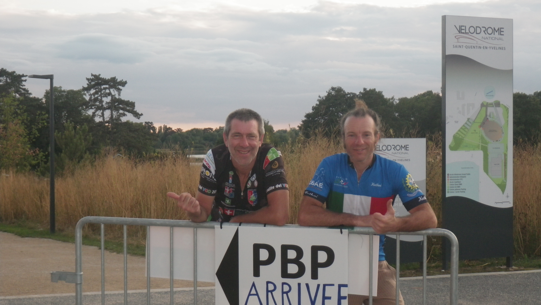
Humility has been my strength, as much as the respect for the enterprise, so big that I’ve doubted I could make it until the end. I hope to have those values always in the future, they’re never enough.
I thank all those that, in many ways, have helped me and have been in my thoughts before, during and after the ride.
Dedicated to Izia Cupillard

Lorenzo Dalle Ave

