Peace Fall Equinox Brevet (2012)
E.W. (Wim) Kok
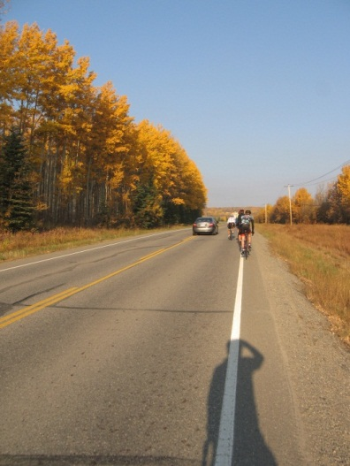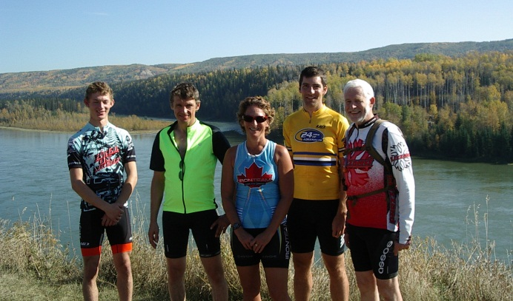
The participants Photo Credit: Bill Lindsay
The Fall Equinox Brevet was the last one of the 2012 season in the Peace. There is nothing as inviting for a bicycle ride as the promise of a gorgeous route and great weather. We had both for the 200 km ride from Fort St. John to Hudson Hope and back. Five riders responded to the invitation: BC Randonneurs Erik Snucins, Barb Polehoykie and I were joined by Jay Morrison and Jakob Graham. The latter two joined us for the challenge and the training. Slightly after 7 am we left the City of Fort St John behind us. While the day promised to be warm, we did feel the early morning chill in a couple of low lying areas. The countryside showed the full glory of the fall season. Some fields left with only stubble, after the grain was harvested; others with the harvest rounded up. In places the foliage was stunning
Horizon separating sky from land Hay roundup completed.
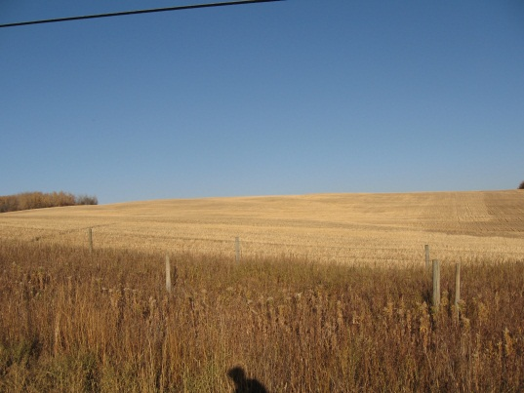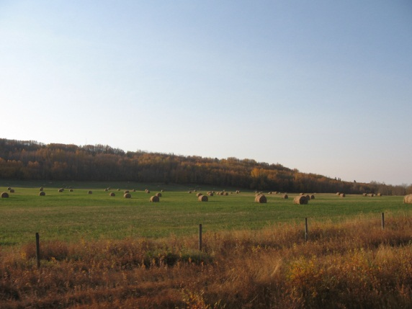
From the countryside we cycled along Charlie Lake’s shore, enjoyed the peaceful waters of the lake, then quickly turned our attention and effort to a steep climb. After the first control (Mile 54 Alaska Highway) we turned on to Hwy 29, the scenic route to Hudson Hope through the Peace River valley. As the sun rose higher in the sky, the temperatures moved accordingly, so did our level of comfort. The increased daylight exposed the vibrancy of the colours of the aspen and poplars. Mother Nature displayed the full range of yellows on its palette.
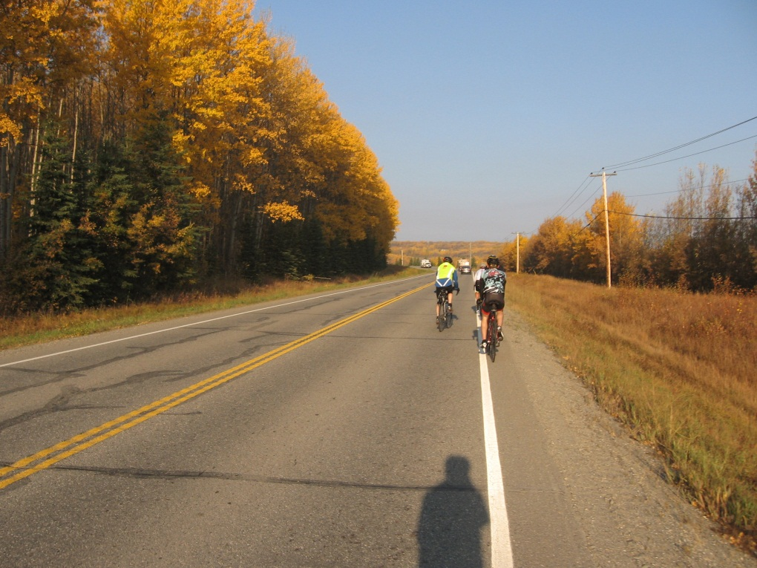
Fall colours along Hwy 29 to Hudson Hope 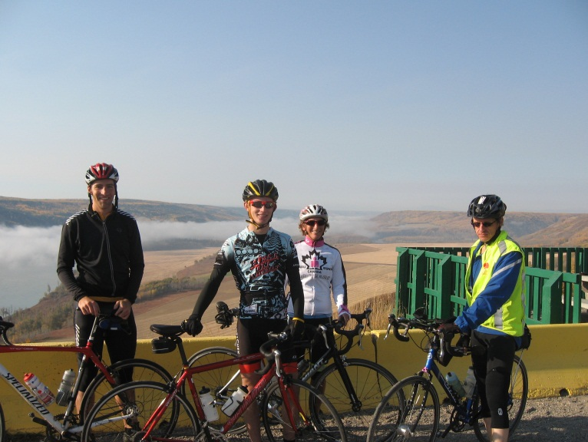
Jay, Jakob, Barb and Erik enjoying the break at the Halfway lookout.
Below and in the distance was a thick valley fog hiding everything in sight. On our minds of course was the thought of cycling into and through this soup, which would have been a cool and moist affair. However as we rested, the fog quickly lifted.
Valley fog below the Halfway River viewpoint
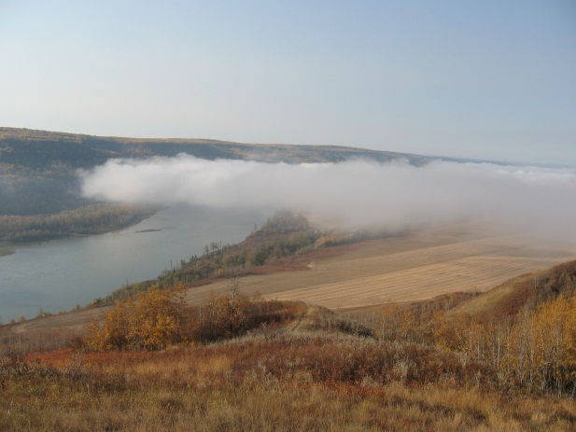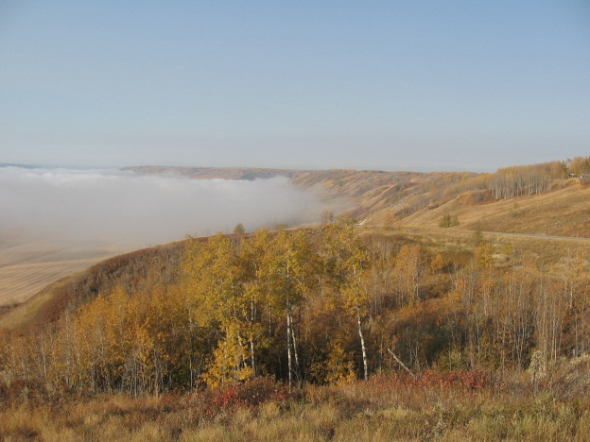

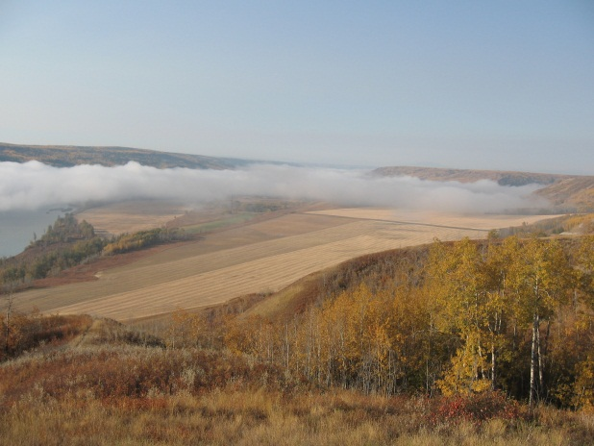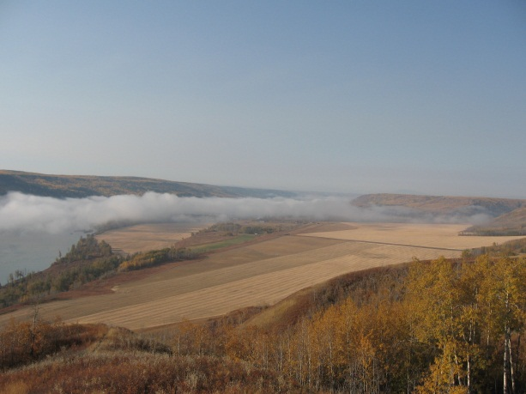
Fog lifting quickly (interval < 5 minutes)
We resumed the ride with a speedy and fast descent, then crossed the Halfway River. Not long thereafter we past a pasture with a grain field. Some 50 meters from the road was a 3-year old black bear, down on all fours, leisurely munching away at some oat straw. We stopped to take a couple of pictures. Blackie then decided to get up, which was a sign for us to get moving too.
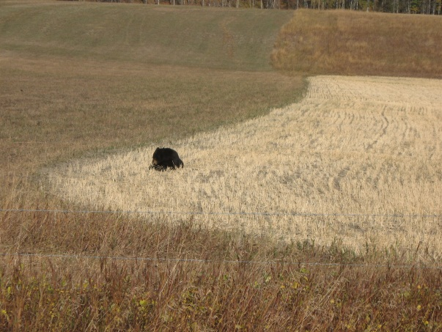 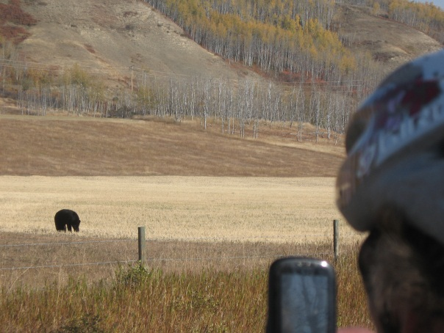
Black bear munching oats Barb snapping the bear in action
As we approached Hudson Hope, Bill Lindsay met us and took a few action pictures. Bill is a long standing member of the Blizzard Cycling Club. Every time a brevet comes through Hudson Hope Bill is there to greet us and provide supplies and services. Bill recently returned from an 8,000 km trip across Canada supporting two cyclists in their effort to raise funds for the BC Cancer Foundation (http://www.journeyforhope.ca/day-74-welcomed-home-family-friends-vancouver/
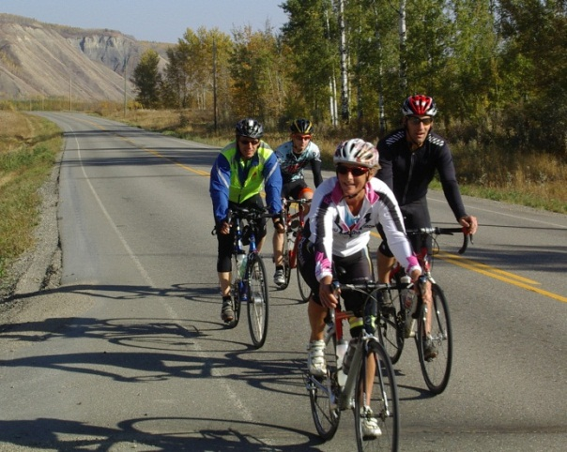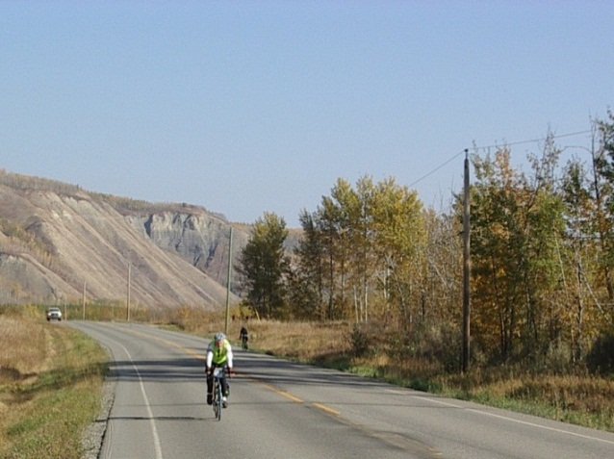
Erik, Jakob, Barb and Jay. Wim Credit: Bill Lindsay
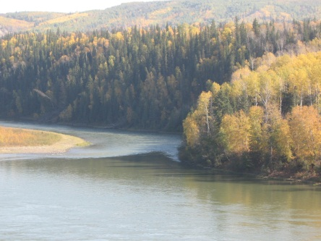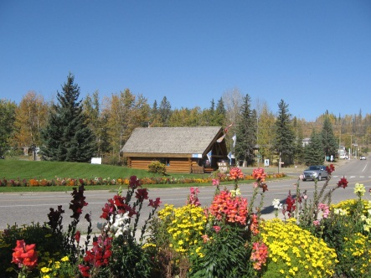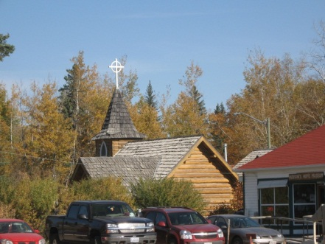
Hudson Hope: Peace River Tourist Info Old Log Church
Following the turn around, we sat down on the banks of the Peace for lunch. We spent more than an hour, probably too long. The first section back to the Halfway River viewpoint ran quite smoothly, although a light SE breeze tried to work against us. So did the 10% hill up to the viewpoint. It was getting pretty hot by now. Erik recorded a high of 31C. The next 15 km or so brought us closer to the Bear Flats hill, which offers a climb of about 7 km with variable grades. That part is always a grunt. The climb is rewarded with a fast descent succeeded by yet another climb. Once that one is out of the way the rest is relatively easy the finish.
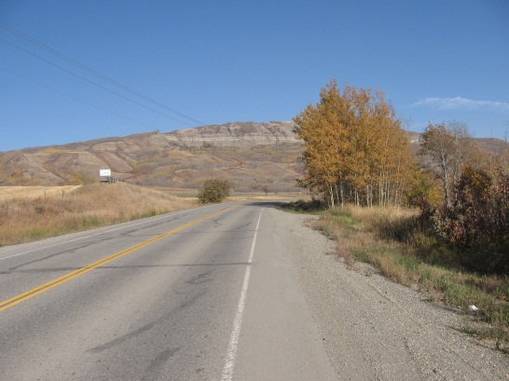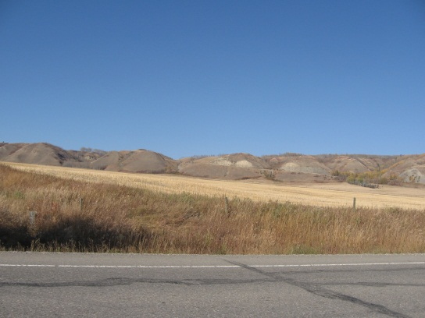
Bear Flats hills looming. Beginning of the 7 km ascent
While Erik, Jay and I are PBP ‘anciens’ and have completed quite few brevets over the years, special mention should be made of the other two riders. First Barb is a successful triathlete who has completed many Ironmen events, most recently the Penticton Ironmen. The other participant was 16 yr. old Jakob Graham, who as a passionate speed skater and avid cyclist was keenly interested in trying out a 200 km ride. Well done.
The Brevet finishers: Wim, Barb and Erik
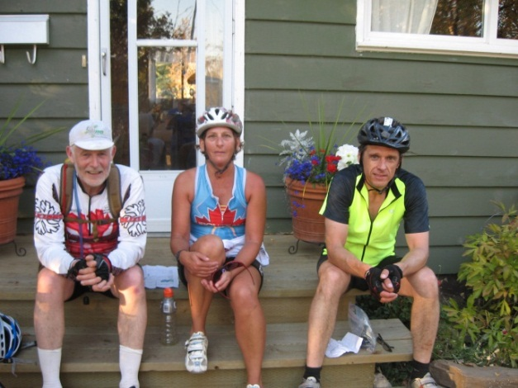
Photo Credit: Ricky Kok
Note: Photo Credits Wim (except for the four identified)

